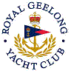 | Royal Geelong Yacht Club Inc.  Est 1859
Trophy Deed of Gift.

Trophy: | H P Douglass Memorial Shield
Presented by: | L. Bechervaise
Date: | 1-Nov-1927
For: | Geelong to Portarlington Race Combined Handicap
Remarks / Revisions | Season 2008-2009:  Division 2 Removed to W. Mackinlay Trophy
Click here to View Recipients

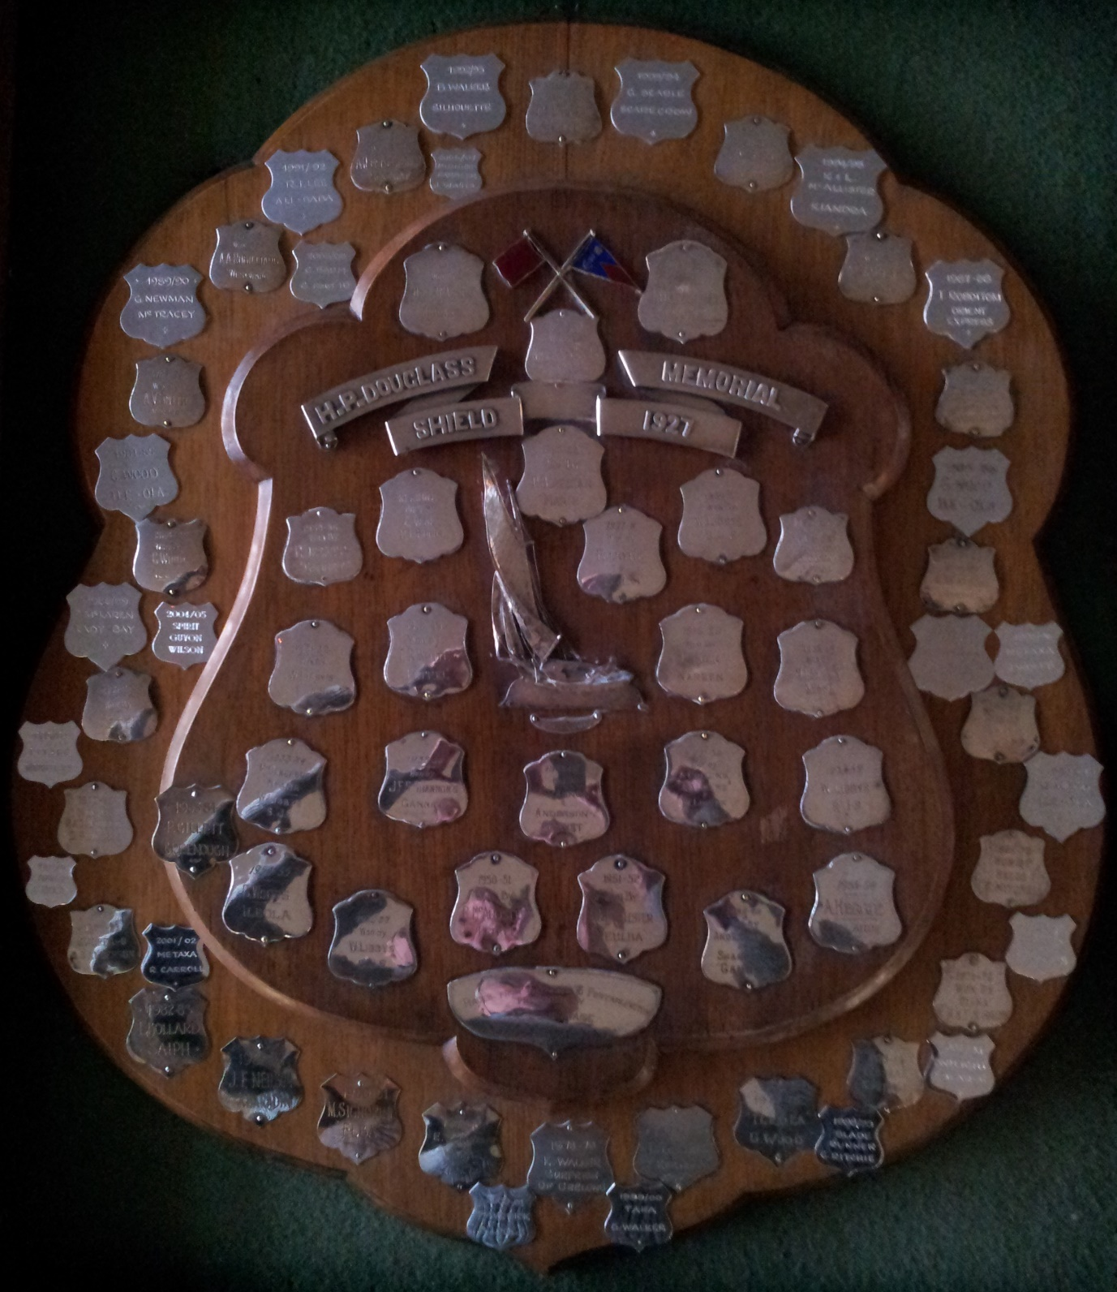
This Shield was hand crafted by Mr C. H. (Chick) Fleet (Snr), a pre-WW2 Club Secretary who trained as a gold smith and later became a jeweller.

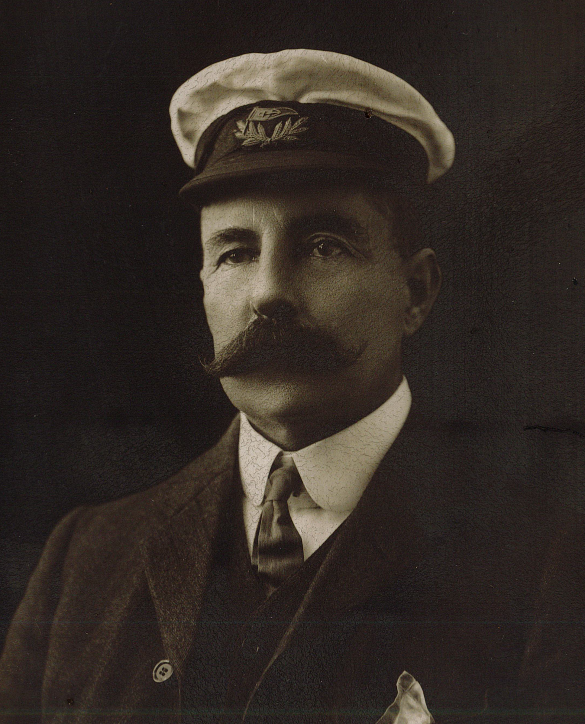

Mr H. P. Douglas

